SIMATS ENGINEERING
CSA04 – OPERATING SYSTEMS
ASSIGNMENT 1 (CO1)
Evaluate and Justify the Operating-System Design of a Smart Hospital
Bloom's level K5 – Evaluate | Total marks: 50 | Tasks 1–12
Field | Details
Student name | Barath S
Register number | 192521359
Course | CSA04 – Operating Systems
Course outcome | CO1 – operating-system types, structures and system calls
GitHub repository | CSA04-192521359-Assignment1 : ______________________________________
Compiler / OS used | gcc 13.3.0, Ubuntu 24.04.5 LTS
Date of submission

Contents: Task 1 Requirements · Task 2 OS types · Task 3 Structures · Task 4 Services · Task 5 System calls · Task 6 Cost of system calls · Task 7 Process control · Task 8 CPU states and protection · Task 9 Memory hierarchy and I/O · Task 10 Measurements · Task 11 Final plan · Task 12 Design challenge · Appendices (repository, listings, viva).

TASK 1 – Evaluate the Requirements of Each Computing Environment (4 Marks)
The hospital is not one computer but six very different environments. Each one is evaluated below against five requirements: response time, reliability, throughput, battery/power and security. Rank 1 means most important for that environment.
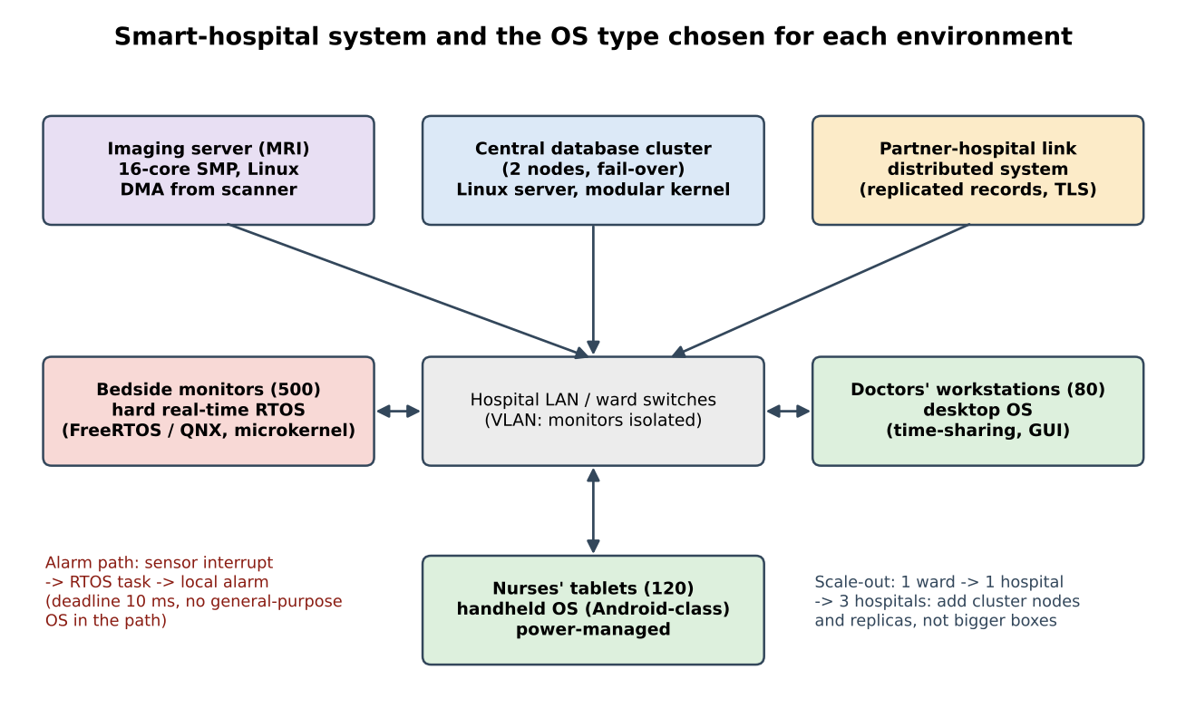
Figure 1.1 – The hospital system, with the operating-system type chosen for each environment (justified in Tasks 1–3).

1.1 Ranked requirement table
Environment | Response time | Reliability | Throughput | Battery / power | Security | Justification of the ranking
Bedside monitors (500) | 1 (hard 10 ms) | 2 | 5 | 4 (backup battery) | 3 | A missed alarm can kill, so the 10 ms deadline outranks everything. Data volume is tiny (a few hundred bytes/s), so throughput is least important. Mains powered, so battery matters only during a power cut.
Nurses' tablets (120) | 3 (soft, ~100 ms) | 4 | 5 | 1 | 2 | The tablet must last a full shift (8–12 h) or it is useless at the bedside. A lost tablet exposes patient data, so security is second. A slow touch response is annoying but not dangerous.
Doctors' workstations (80) | 1 (interactive) | 3 | 4 | 5 (mains) | 2 | Doctors wait on screens all day, so interactive response and fair sharing between users come first; records are opened and edited, so security is next.
Central database server | 4 (tens of ms) | 1 (never stop) | 3 | 5 (UPS) | 2 | Every other system depends on it: downtime stops care. Wrong or leaked records harm patients, so integrity/security is second; transactions/s is third.
Imaging server (MRI) | 4 | 2 | 1 | 5 | 3 | An MRI study is 100s of MB to GB and many are queued, so work done per hour (throughput) dominates; a crash only repeats a reconstruction.
Partner-hospital link | 4 | 2 | 3 | 5 | 1 | Records cross an organisation boundary over a network the hospital does not control, so confidentiality and authentication come first; latency of seconds is acceptable.

1.2 Which requirements conflict?
Conflict | Why it arises | How the design resolves it
Fast response vs many users on one machine | Time-sharing gives every user a slice; more users mean longer waits and more context switches. | Keep the alarm path off the shared machine (monitors have their own real-time OS). Workstations serve one doctor each.
Response time vs throughput | A long CPU quantum raises throughput (fewer context switches) but delays short interactive jobs. | Different scheduler per environment: priority/deadline on monitors, interactive on workstations, large-quantum batch on the imaging server.
Reliability vs updates | Security patches often need a reboot, but the database must never stop. | Cluster with fail-over: patch one node at a time (rolling update).
Battery vs response | Deep sleep saves power but wakes slowly; polling keeps the CPU awake. | Interrupt-driven I/O and aggressive power management on tablets (Task 8).
Security vs response / battery | Encryption, authentication and access checks cost CPU time and energy. | Hardware crypto (AES instructions), session reuse, and a light protocol on monitors.

1.3 Requirements that are critical to patient safety
- Alarm latency ≤ 10 ms on the monitors (a deadline, not an average).
- Database availability and integrity: the right record for the right patient, always reachable, never half-written after a crash.
- Correct time and ordering of events (medication and alarm logs) – required for clinical audit.
- Isolation: a crash in a tablet app or workstation program must not affect monitors or the database.
- Battery life and throughput are important for efficiency but are not directly life-critical.

1.4 Lessons from the history of operating systems
Era | Lesson | Where it applies in the hospital
Batch (1950s–60s) | Maximise processor utilisation by running queued jobs without a user waiting. | MRI reconstruction and overnight record back-ups on the imaging server.
Time-sharing (1960s–70s) | Give each user a short slice so the machine feels private; add memory protection and file permissions. | Doctors' workstations and the multi-user database server.
Personal computers | One user, a GUI, low cost, little protection originally – later re-learned from time-sharing. | Workstations: a desktop OS with a GUI, but with user accounts and protection restored.
Mobile / handheld | Battery, touch, app sandboxing and aggressive power management. | Nurses' tablets: Android-class OS.
Real-time / embedded | Correctness depends on meeting deadlines; predictability beats average speed. | Bedside monitors: hard real-time OS.
Distributed / clustered | Share work and data across machines; survive the failure of one. | Database cluster and the link to partner hospitals.

1.5 Alternative concept and complexity analysis: one general-purpose OS everywhere
Solution if it were used. Every device would run the same general-purpose OS (for example standard Linux or Windows) with the same scheduler, memory manager and update system. Only the application would differ.
Criterion | Different OS per environment (chosen) | One general-purpose OS everywhere | Complexity / comment
Worst-case alarm response | Hard real-time scheduler: a priority-based pre-emptive scheduler with bounded interrupt latency. Worst case = deadline, e.g. < 1 ms for a few tasks. | A fair-share scheduler (CFS) has no deadline. Under load, a page fault, disk flush, driver or update can delay the alarm task by tens to hundreds of ms – unbounded in the worst case. | Worst-case latency: O(1), bounded, vs. not bounded (depends on load, O(#runnable tasks) wake-up delay).
Memory per device | RTOS kernel from about 10 KB (FreeRTOS) to a few hundred KB (microkernel); whole image typically 1–64 MB. | Typically 512 MB–2 GB RAM and several GB of storage for a full OS. | 500 monitors × ~1 GB = ~500 GB of RAM in total vs. about 500 × 32 MB = 16 GB. Space: O(D·M_gpos) vs. Σ O(D_i·M_i).
Administration effort | Several OS families, tool-chains and skills (4–5). | One image, one patch process, one skill-set. | Effort O(k) for k OS families vs. O(1) – but a single patch then touches all 500 critical monitors, so every update needs a staged roll-out.
Figures such as 512 MB–2 GB and ‘tens to hundreds of ms’ are typical engineering values, not measurements from this assignment.
Conclusion. The saving in administration does not justify the loss of a latency guarantee. The IT proposal fails the patient-safety requirement; one OS everywhere is rejected for the monitors, but it is acceptable (and cheaper) for workstations.

TASK 2 – Judge the Type of Operating System for Each Environment (3 Marks)

2.1 Comparison of operating-system types
Type | Main idea | Strength | Weakness | Hospital fit
Mainframe | Very large, batch/transaction oriented, extremely reliable. | Throughput, RAS (reliability, availability, serviceability). | Costly, specialist skills. | Not needed: clusters of commodity Linux servers reach the required availability.
Desktop | Single user, GUI, time-sharing of one CPU. | Usability, wide software support. | Not real-time, large footprint. | Doctors' workstations.
Multiprocessor (SMP/AMP) | Several CPUs share memory under one OS. | Throughput, graceful degradation. | Memory/lock contention, one OS image = one failure domain. | Imaging server.
Distributed | Many machines appear as one system; communicate by messages. | Sharing, scalability, fault tolerance. | Network delays, complexity, security. | Link to partner hospitals; later cloud records.
Clustered | Machines share storage and monitor each other; fail-over. | High availability, load sharing. | Needs fencing, split-brain avoidance, more hardware. | Central database.
Hard real-time | Deadlines are guaranteed (missing one is a failure). | Predictable worst case. | Limited features, low average throughput. | Bedside monitors.
Soft real-time | Deadlines are met on average; occasional miss tolerated. | Better throughput than hard RT. | No guarantee. | Video of the MRI viewer, telemetry display.
Handheld | Small devices, battery, touch, limited memory. | Power management, app sandboxing. | Limited resources, fragmented OS versions. | Nurses' tablets.

2.2 Chosen type for each environment, with rejected alternatives
Environment | Chosen type | Rejected alternatives and reasons
Bedside monitors | Hard real-time OS (FreeRTOS on small boards, QNX-class RTOS where isolation is needed) | Desktop/general-purpose: no deadline guarantee. Soft real-time: a missed alarm is a safety failure. Handheld OS: scheduler tuned for battery/UI, not deadlines.
Nurses' tablets | Handheld OS (Android-class) with mobile-device management | Desktop OS: heavier, shorter battery (Task 4). Real-time OS: no apps/UI ecosystem needed for charts and barcode scanning.
Doctors' workstations | Desktop OS (Windows or Linux desktop) | Handheld: screen/input unsuitable. Real-time: unnecessary for interactive work.
Central database server | Clustered Linux server OS (2 nodes, fail-over, shared/replicated storage) | Single large SMP machine: single point of failure (Section 2.4). Mainframe: cost and skills. Desktop OS: not designed for multi-user, 24×7 operation.
Imaging server | Symmetric multiprocessor Linux server, batch-style queue | Asymmetric multiprocessing: master CPU becomes the bottleneck. Cluster: only needed if one server is not enough.
Partner link | Distributed system: replicated records between sites over TLS/VPN | Direct shared-disk access across sites: not secure, not tolerant of WAN delays.

2.3 Symmetric versus asymmetric multiprocessing for the imaging server
 | Symmetric (SMP) | Asymmetric (AMP)
Scheduling | Every CPU runs the same kernel and picks work from a shared (or per-CPU) run queue. | One master CPU runs the OS and assigns work; slaves only run user code.
Throughput | Scales with the number of cores until locks and memory bandwidth limit it. | Master is a bottleneck: all system calls and I/O pass through it.
Failure | Loss of one CPU reduces capacity only. | Loss of the master stops the system.
Complexity | Needs fine-grained locking in the kernel. | Simple kernel.
Decision | Chosen – MRI reconstruction splits into many independent slices. | Rejected.

2.4 Clustered system with fail-over for the database server
Two (or three) nodes run the database OS. A heartbeat is exchanged every second; if the active node stops answering, the standby takes over the virtual IP and the replicated data within seconds. A fencing step (power off the failed node) prevents ‘split-brain’, in which both nodes write the same data. Rolling updates (patch standby, fail over, patch the old active) remove planned downtime.

2.5 Alternative concept and complexity analysis: one large multiprocessor instead of a cluster
Solution if it were used. One very large SMP machine (for example 64 cores, 2 TB RAM) would run the database with redundant power supplies but one OS image and one motherboard.
Availability. With availability A = MTBF / (MTBF + MTTR) and illustrative values MTBF = 2,000 h, MTTR = 4 h (repair or replacement), a single machine has A = 2000/2004 = 99.80 %, i.e. about 17.5 h of downtime per year. For two nodes of the same quality, the system fails only if both are down (unavailability ≈ 0.002² = 4×10⁻⁶ ≈ 2.1 min/year) plus fail-over time: 8.76 node failures/year × 30 s ≈ 4.4 min. Total ≈ 6.5 min/year ≈ 99.9988 %.
Throughput growth with processors (time). By Amdahl's law the speed-up with N processors and parallel fraction p is S(N) = 1 / ((1 − p) + p/N). For p = 0.95:
Processors N | 1 | 2 | 4 | 8 | 16 | 32 | 64 | ∞
Speed-up S(N) | 1.00 | 1.90 | 3.48 | 5.93 | 9.14 | 12.55 | 15.42 | 20.0

Doubling the processors from 32 to 64 buys only 23 % more throughput, so throughput grows as O(N) only while the serial fraction is small. A cluster scales by adding nodes and partitioning data (sharding), at the cost of distributed-transaction complexity.
Criterion | Cluster with fail-over (chosen) | One large multiprocessor
Availability | ≈ 99.999 % (fail-over in seconds) | ≈ 99.8 % (single point of failure; hours to repair)
Cost | Two mid-range servers + shared storage / replication. | One high-end machine costs much more per core and per GB (non-linear pricing); still needs a second machine for real safety.
Throughput (time) | Grows by adding nodes; limited by replication traffic. | Grows with cores to the Amdahl limit; lock/NUMA contention.
Memory (space) | RAM per node is smaller; data is replicated, so total RAM needed is about 2×. | One large shared memory; no replication of RAM.
MTBF, MTTR and p are illustrative assumptions chosen to show the method; use the vendor's real figures in practice.

TASK 3 – Evaluate Operating-System Structures (4 Marks)

3.1 Comparison of structures
Structure | Description | Reliability | Performance | Ease of updating
Simple / monolithic | All OS services in one kernel address space. | Low: any driver bug can crash the kernel. | High: a service request is one system call, no message copying. | Poor unless modular: rebuild/reboot.
Layered | OS split in layers; each layer uses only the one below. | Good: easier to debug layer by layer. | Lower: a request passes through every layer. | Moderate: change one layer.
Microkernel | Only scheduling, IPC and basic memory in the kernel; drivers, file system and network run as user-mode servers. | High: a failed server is restarted; kernel is small and verifiable. | Lower: services communicate by messages (extra copies and context switches). | Good: replace a server without rebooting.
Modular (loadable kernel modules) | Monolithic core + modules loaded at run time. | Moderate: a bad module still runs in kernel mode. | High (same as monolithic). | Good: load/unload drivers live.
Hybrid | Mixture: microkernel ideas + some services in kernel for speed. | Moderate–high. | Good. | Good.

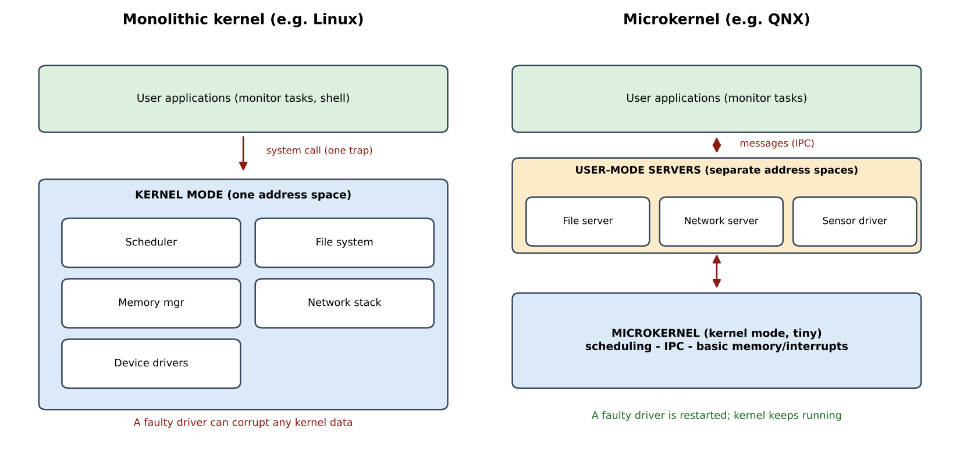
Figure 3.1 – Monolithic and microkernel structures. In the microkernel a faulty driver is just a user process.

3.2 How real systems are structured
System | Structure | Notes
Linux | Monolithic kernel with loadable kernel modules. | Drivers, file systems and network stack run in kernel mode; modules (.ko) can be loaded without rebooting.
Windows (NT) | Hybrid kernel. | Executive services and drivers in kernel mode, user-mode subsystems and services above; the HAL hides hardware.
Android | Linux kernel + layered user space (HAL, native libraries, ART runtime, application framework, apps). | Layered on a monolithic kernel.
FreeRTOS | Tiny single-address-space kernel (scheduler, queues, semaphores, timers) linked with the application. | Kernel can be about 6–12 KB; no memory protection except in the optional MPU version.
QNX | True microkernel RTOS. | Drivers, file systems and protocols are user-mode processes talking by message passing; restartable.

3.3 Defended choices
- Patient monitors – microkernel RTOS (QNX-class) where isolation is required, FreeRTOS on the smallest devices. A faulty sensor or network driver must never stop the alarm task; with a microkernel the driver runs in its own address space and is restarted in milliseconds. A small kernel also has a predictable worst-case interrupt latency and is easier to certify for medical use.
- Database server – monolithic Linux with loadable modules. Throughput of file and network I/O matters most; the cluster, not the kernel structure, provides fault tolerance. Modules allow updating storage and network drivers without a reboot.

3.4 Alternative concept and complexity analysis: monolithic kernel on the monitors
Solution if it were used. The monitors would run a monolithic kernel (for example a stripped Linux): the sensor driver, network stack and file system all run in kernel mode, and the alarm task obtains services by system calls.
Measured system-call cost on the test machine (Task 6): a system call (getppid) costs about 110 ns against 1.4 ns for an ordinary function call. In a microkernel the same service needs a request message and a reply (two IPC operations and two context switches); typical published figures for microkernel IPC are a fraction of a microsecond to a few microseconds, so the cost per request is a constant factor higher but still O(1).
Criterion | Microkernel (chosen) | Monolithic kernel
Time per service request | Message to server + reply: 2 IPC + 2 context switches (about 1–5 µs typical). Complexity O(1) with a larger constant. | One system call (about 0.1 µs measured on the test machine). O(1).
Kernel memory | Tens to a few hundred KB of kernel code; servers loaded only as needed. | Several MB to tens of MB of kernel image plus modules.
Effect of a faulty driver | Only that server fails; the kernel restarts it. Alarm task continues. | Driver runs in kernel mode: a wild pointer can corrupt the kernel and crash the whole monitor – the alarm is lost.
Evaluation. The extra microseconds per service request are far below the 10 ms deadline (less than 0.05 %), so they do not threaten the requirement, while fault isolation directly protects it. The microkernel is therefore kept for the monitors.

TASK 4 – Evaluate the Services an Operating System Must Provide (4 Marks)

4.1 Service table for each environment
✔ = provided in full, ◐ = reduced/minimal, ✘ = removed.
Service | Bedside monitor | Tablet | Workstation | Database server | Imaging server
User interface | ✘ (small fixed display) | ✔ touch GUI | ✔ GUI | ◐ shell/SSH only | ◐ shell/SSH only
Program execution | ◐ fixed tasks, no dynamic loading | ✔ apps | ✔ | ✔ (service processes) | ✔ (job queue)
I/O operations | ✔ interrupt-driven sensor and network I/O | ✔ touch, camera, barcode, Wi-Fi | ✔ | ✔ (disk, network) | ✔ with DMA
File system | ◐ tiny flash file system for settings/logs | ✔ app storage | ✔ | ✔ journaling, large volumes | ✔ large files
Communication | ✔ network to central station | ✔ | ✔ | ✔ (replication, client) | ✔
Error detection | ✔ watchdog timer, sensor self-test | ✔ | ✔ | ✔ ECC, RAID, logs | ✔
Resource allocation | ◐ static priorities/CPU budget | ✔ power-aware | ✔ | ✔ | ✔
Accounting | ✘ | ◐ | ◐ | ✔ audit of every access | ◐
Protection & security | ✔ signed firmware, MPU | ✔ sandbox, encryption | ✔ accounts, MFA | ✔ ACLs, MAC, encryption | ✔

4.2 Services removed from the bedside monitor, and services essential to the database
- Removed from the monitor to make it smaller and faster: graphical interface, user accounts and logins, dynamic program loading, virtual memory/swapping, general-purpose multi-user file system, printing, and most of the network protocols. Fewer services mean less code to fail, a smaller memory footprint and a more predictable worst-case latency.
- Essential for the database server: a reliable journaling file system, resource allocation across many users, protection and authentication, error detection and recovery (RAID, ECC, logging), communication for replication and clients, and accounting/auditing (who read which record).

4.3 How the OS protects one patient's records from another user's programs
- Authentication – each user/service has an account; staff log in with MFA.
- Access control – owner/group/other permission bits and ACLs on every file or table; mandatory access control (for example SELinux) restricts which program may open which data.
- Memory protection – the MMU gives each process its own address space; a program cannot read another process's memory (demonstrated in Task 8).
- Mode bit / system calls – programs reach files only through system calls, where the kernel checks the permission of the caller on every open().
- Encryption and audit – data encrypted at rest and in transit; all access logged.

4.4 Alternative concept and complexity analysis: full desktop OS on the tablets
Solution if it were used. The nurses' tablets would run a complete desktop OS with every service (full file systems, printing, multi-user accounts, background services) instead of a reduced handheld OS.
Criterion | Reduced handheld OS (chosen) | Full desktop OS, all services
Memory (space) | Typically 1–2 GB RAM is enough. | Typically 4 GB or more for the base system plus background services.
Storage (space) | About 6–10 GB for the OS image. | 20–40 GB or more.
Start-up time | About 10–20 s (or instant wake from sleep). | 30–60 s, more services to start.
Battery life (time) | 10–12 h per shift with aggressive power management (sleep, wake locks, app standby). | About 4–6 h: more background tasks keep the CPU awake and the desktop OS assumes mains power.
Values are typical orders of magnitude for comparison. In Big-O terms, memory and boot time grow as O(number of enabled services); battery life falls with the total CPU wake-up time.
Evaluation. The desktop OS fails the first-ranked tablet requirement (battery for a full shift), so the reduced handheld OS is retained.

TASK 5 – Examine System Calls (4 Marks)

5.1 Categories of system calls
Category | Purpose | Linux examples | Hospital example
Process control | Create, run, wait for and end programs; allocate memory. | fork, execve, wait4, exit, brk, mmap | The shell starts a back-up job.
File management | Create, open, read, write, close, delete files. | open, read, write, close, unlink, stat | Database reads a patient record file.
Device management | Request/release devices; read, write, ioctl. | ioctl, read/write on /dev files | Imaging server reads from the scanner.
Information maintenance | Get/set time, date, system or process attributes. | getpid, gettimeofday, uname | Time-stamp an alarm.
Communication | Create connections, send/receive messages, share memory. | pipe, socket, send, recv, shmget | Database talks to the partner hospital.
Protection | Control access to resources. | chmod, chown, umask, setuid | Restrict a record to its care team.

5.2 What happens, step by step, when a program calls read()
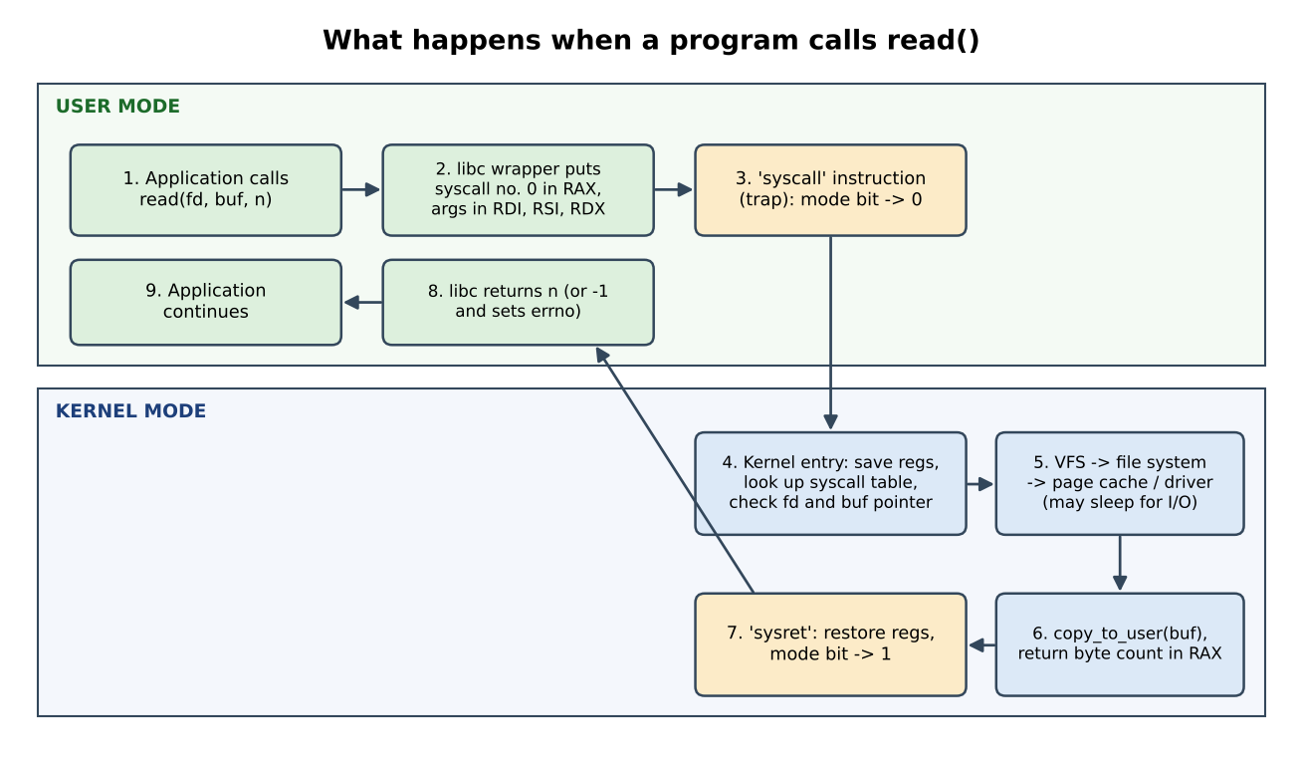
Figure 5.1 – The path of a read() system call (Linux x86-64).
- Library call. The program calls read(fd, buf, n), a wrapper in the C library (libc).
- Prepare. The wrapper puts the system-call number (0 for read) in register RAX and the arguments in RDI, RSI and RDX.
- Trap. The wrapper executes the syscall instruction, a software trap; the hardware saves the user program counter, switches the mode bit to kernel mode and jumps to the kernel entry point.
- Kernel entry. The kernel saves the remaining registers, uses the number as an index into the system-call table, and validates the arguments (is fd open? is buf a valid user address?).
- Kernel work. The virtual file system finds the file's file system, which looks in the page cache; on a miss it asks the driver to read the disk block and the process sleeps (waiting state) until the I/O-completion interrupt.
- Copy and return. The kernel copies the data into the user buffer (copy_to_user) and places the byte count (or −errno) in RAX.
- Mode switch back. sysret restores the registers and switches the mode bit back to user mode; libc returns n (or −1 with errno set) and the program continues.

5.3 Parameter passing
Method | How it works | Used by | Trade-off
Registers | Number and arguments are placed in CPU registers. | Linux x86-64 (RAX, RDI, RSI, RDX, R10, R8, R9) | Fastest; limited to a few arguments.
Block (table) in memory | Arguments are stored in a block; its address is passed in a register. | Some Linux calls with many parameters, Solaris | Any number of parameters; one extra memory access and a pointer to validate.
Stack | Arguments are pushed by the program and popped by the OS. | Older x86 systems, some other OSes | Unlimited length; slower.

5.4 Evidence: strace of a real program
The program read_demo (Task05/read_demo.c) opens patient.txt, reads it with read(), writes it to the terminal and closes it. The last lines of strace show the system calls made:
#define _POSIX_C_SOURCE 200809L
#include <fcntl.h>
#include <unistd.h>
#include <stdio.h>
int main(void)
{
char buf[64];
int fd = open("patient.txt", O_RDONLY); /* file management */
if (fd < 0) { perror("open"); return 1; }
ssize_t n = read(fd, buf, sizeof buf); /* the system call under study */
write(STDOUT_FILENO, buf, (size_t)n); /* device management (terminal) */
close(fd);
return 0;
}
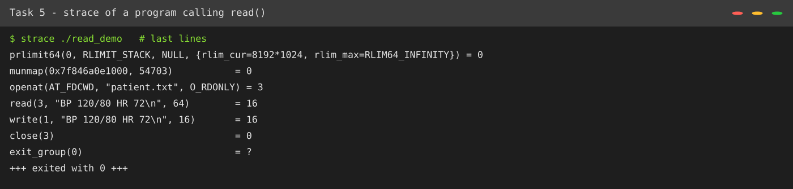
Figure 5.2 – strace output of read_demo: openat → read → write → close → exit_group.
The line read(3, "BP 120/80 HR 72\n", 64) = 16 shows the system-call name, its arguments (descriptor 3, the buffer contents, the requested size 64) and the return value (16 bytes actually read, shorter than requested). The earlier openat returned descriptor 3; the write to descriptor 1 (standard output) is device management.

5.5 Alternative concept and complexity analysis: fopen/fread/fwrite instead of open/read/write
Solution if it were used. The program calls the C-library functions fopen, fread and fwrite. The library keeps a buffer (4,096 bytes here, because glibc uses the file's block size) and calls read() or write() only when the buffer is empty or full.
FILE *in = fopen(src, "rb"), *out = fopen(dst, "wb");
int c;
while (fread(&c, 1, 1, in) == 1) /* 1 byte per library call */
fwrite(&c, 1, 1, out); /* the real read()/write() happen once per 4 KB */
fclose(in); fclose(out);
Measured (strace -c, 1 MiB file, 1 byte per library call): 1,048,576 fread + 1,048,576 fwrite calls resulted in only 258 read() and 257 write() system calls (1 MiB / 4096 = 256, plus the end-of-file read and start-up). Calling read(fd, buf, 1) directly needed 1,048,576 system calls – 4,096 times more.
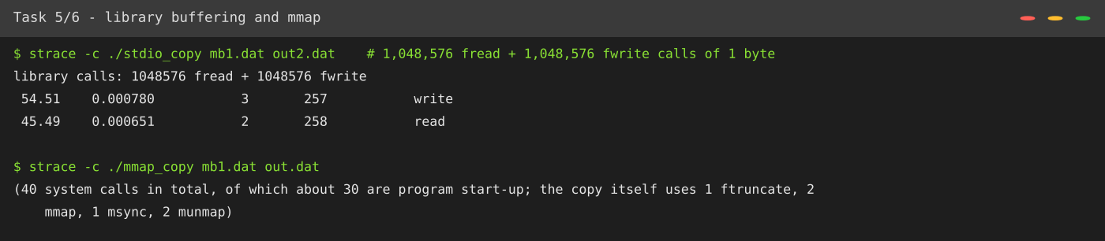
Figure 5.3 – Library buffering and mmap (measured with strace -c).
Criterion | Direct read/write with buffer b | fread/fwrite (library buffer 4 KB)
System calls for a file of n bytes | n / b (a program choosing b = 1 makes n calls) | about n / 4096, whatever the program's chunk size
Time complexity | O(n / b) calls × cost of a system call | O(n / 4096) system calls + O(n) cheap library calls (1.4 ns each)
Extra space | Buffer of the program's choice, b bytes | Library buffer of 4 KB per open file: O(1) per file
Control | Exact control (O_DIRECT, large buffers, sockets) | Portable and simple, less control over timing of writes (needs fflush)

TASK 6 – Evaluate the Cost of System Calls (4 Marks)

6.1 Why does a system call cost more than a function call?
An ordinary function call is a jump and a return inside one address space (a few instructions). A system call must: (1) trap into kernel mode, (2) save and later restore registers, (3) switch stacks, (4) validate every argument and pointer (the kernel cannot trust the program), (5) possibly flush parts of the pipeline or TLB for security mitigations, and (6) return. The measurement below (Task06/syscall_cost.c, 5,000,000 iterations) confirms the difference:
Operation | Time per call (measured) | Relative
Ordinary function call | 1.4 ns | 1×
System call (getppid) | 109.7 ns | ≈ 76×
The real read() is more expensive still than getppid, because it also looks up the file and copies data.

6.2 Complete the Code – copy_file with read() and write()
TODO 1 was completed with a loop that reads up to bufsize bytes, counts every read call (including the final one that returns 0), stops at end-of-file (0) or error (−1), and writes exactly the n bytes that were read:
#define _POSIX_C_SOURCE 200809L
#include <stdio.h>
#include <fcntl.h>
#include <unistd.h>

/* Copy src to dst with the read() and write() system calls, using a buffer of
bufsize bytes. Returns the number of read() calls made, or -1 on error. */
long copy_file(const char *src, const char *dst, size_t bufsize)
{
char buf[8192];
int in = open(src, O_RDONLY);
if (in < 0) return -1;
int out = open(dst, O_WRONLY | O_CREAT | O_TRUNC, 0644);
if (out < 0) { close(in); return -1; }
long calls = 0;
ssize_t n;
while (1) {
n = read(in, buf, bufsize);
calls++;
if (n <= 0) break;
if (write(out, buf, (size_t)n) != n) { calls = -1; break; }
}
close(in);
close(out);
return calls;
}

int main(void)
{
FILE *f = fopen("records.dat", "w"); /* a 10,000-byte test file */
for (int i = 0; i < 10000; i++) fputc('A' + i % 26, f);
fclose(f);
size_t sizes[] = {1, 512, 4096};
for (int i = 0; i < 3; i++)
printf("buffer %4zu bytes: %5ld read() calls\n", sizes[i],
copy_file("records.dat", "copy.dat", sizes[i]));
unlink("records.dat");
unlink("copy.dat");
return 0;
}
Compiled with gcc 13.3.0: gcc -std=c11 -Wall -Wextra copy_file.c -o copy_file (no warnings).
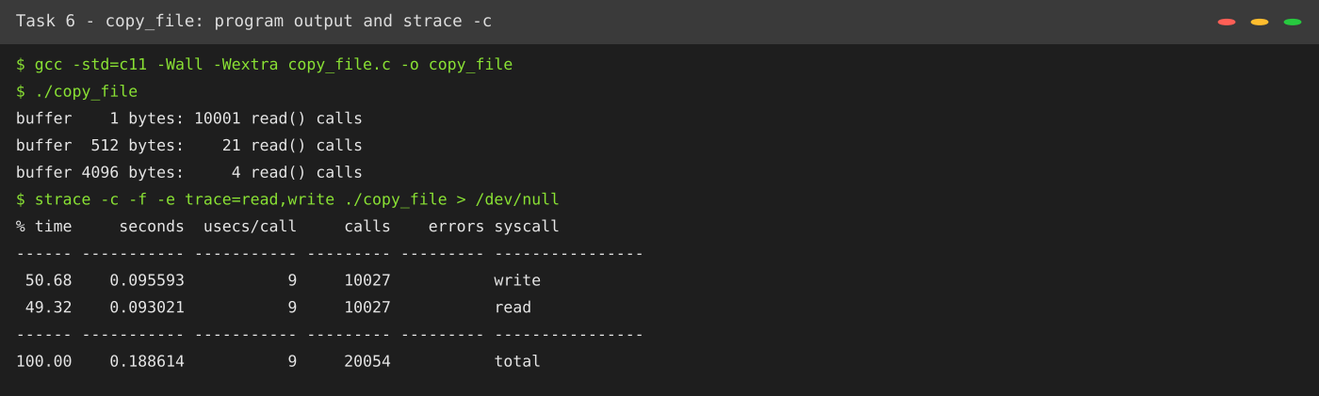
Figure 6.1 – Program output (identical to the expected output) and strace -c.
The given skeleton declares char buf[8192], so bufsize must not exceed 8192 bytes; the test sizes 1, 512 and 4096 are within the limit. Task 10 uses a separate benchmark with a malloc'd buffer for larger sizes.

Comparing strace -c with the program's output
The program reports 10,001 + 21 + 4 = 10,026 read() calls. strace -c reports 10,027 read calls: the extra one is the read() made by the dynamic loader when the program starts (reading the ELF header of libc). The write() count is 10,027 = 10,000 + 20 + 3 (the copy) + 3 (stdio writing the 10,000-byte test file in 4 KB pieces) + 1 (the printf output) – so the program's own numbers and strace agree exactly once these extras are accounted for.

6.3 Effect of buffer size on the number of calls
For a file of n bytes and a buffer of b bytes the copy needs ⌈n / b⌉ + 1 read() calls (the +1 is the end-of-file read) and ⌈n / b⌉ write() calls.
Buffer b (bytes) | File size | read() calls reported by strace -c | n / b (+2 extra) | Real time, 1 MiB copy (no strace)
1 | 1 MiB | 1,048,578 | 1,048,576 + 2 | 0.551 s (user 0.124, sys 0.422)
16 | 1 MiB | 65,538 (computed, not traced) | 65,536 + 2 | 0.038 s
64 | 10 MiB | 163,842 | 163,840 + 2 | 0.011 s
512 | 10 MiB | 20,482 | 20,480 + 2 | 0.004 s
4,096 | 10 MiB | 2,562 | 2,560 + 2 | 0.003 s
65,536 | 10 MiB | 162 | 160 + 2 | 0.003 s
1,048,576 | 10 MiB | 12 | 10 + 2 | 0.003 s
strace counts every read(): the data reads n / b, plus the end-of-file read and the one read made by the dynamic loader at start-up (the 2 extra calls). Real times were taken without strace (best of three runs) on the 1 MiB file, because strace slows the program about 180 times (1 MiB with b = 1: 101 s under strace, 0.55 s without).
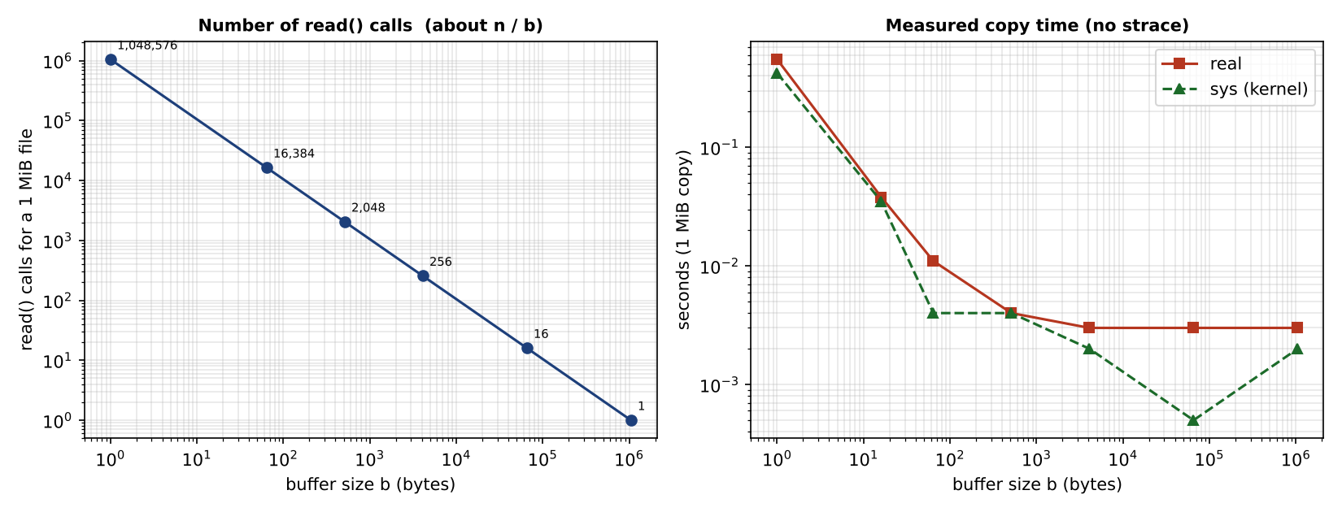
Figure 6.2 – Number of read() calls (left) and measured copy time (right) against buffer size.

6.4 Library buffering
fread/fwrite reduce the number of system calls to about n / 4096 regardless of how small the program's own requests are (258 reads for 1,048,576 one-byte fread calls, Task 5). The price is one 4 KB buffer per open file and the need to flush before fork() or exit (Task 7).

6.5 Best buffer size for the hospital's backup program
The curve falls steeply until about 4 KB and then flattens: going from 1 byte to 4 KB cuts system calls 4,096 times and run time from 0.55 s to 0.003 s, whereas going from 4 KB to 1 MiB changes the time by less than the measurement noise at this file size. Recommendation: 64 KiB (16 × the 4 KiB page size). It needs only 16 read and 16 write calls per MiB (16,384 per GiB), is a multiple of the page and disk-block size so I/O stays aligned, and still fits comfortably in the CPU cache. Buffers beyond about 1 MiB give no further benefit and waste memory when many back-ups run in parallel.

6.6 Alternative concept and complexity analysis: memory-mapped files (mmap)
Solution if it were used. The backup maps the source and destination files into memory and copies with memcpy; the kernel loads pages on demand by page faults instead of read()/write() calls.
#define _POSIX_C_SOURCE 200809L
#include <stdio.h>
#include <string.h>
#include <fcntl.h>
#include <unistd.h>
#include <sys/mman.h>
#include <sys/stat.h>
/* Alternative concept: copy a file through memory-mapped files (a handful of system calls). */
int main(int argc, char **argv)
{
if (argc != 3) return 2;
int in = open(argv[1], O_RDONLY); struct stat st; fstat(in, &st);
int out = open(argv[2], O_RDWR | O_CREAT | O_TRUNC, 0644);
if (ftruncate(out, st.st_size) < 0) { perror("ftruncate"); return 1; }
char *s = mmap(NULL, (size_t)st.st_size, PROT_READ, MAP_PRIVATE, in, 0);
char *d = mmap(NULL, (size_t)st.st_size, PROT_READ | PROT_WRITE, MAP_SHARED, out, 0);
if (s == MAP_FAILED || d == MAP_FAILED) { perror("mmap"); return 1; }
memcpy(d, s, (size_t)st.st_size); /* page faults, not system calls, move the data */
msync(d, (size_t)st.st_size, MS_SYNC);
munmap(s, (size_t)st.st_size); munmap(d, (size_t)st.st_size);
close(in); close(out);
return 0;
}
Measured: copying a 1 MiB file made 40 system calls in total with strace -c, almost all of them program start-up; the copy itself needed about 9 (open ×2, fstat, ftruncate, mmap ×2, msync, munmap ×2) – a constant number, independent of the file size. The result was verified identical with cmp.
Criterion | read()/write() with buffer b | mmap
Number of system calls | about n / b (O(n/b)) | a few (O(1)); data moves by page faults, about n / 4096 of them
Copying kernel ↔ user | Kernel copies into the user buffer for read() and out of it for write() (2 copies) | Source pages of the page cache are mapped directly; only the memcpy copy remains, so one fewer copy
Memory for very large files | O(b), constant, any file size | Virtual address space O(n); resident memory is managed by the OS and can be evicted, but a 32-bit process cannot map more than ~3 GB
Error handling | Return value −1 and errno | I/O errors arrive as the signal SIGBUS, harder to handle
Evaluation. mmap wins for large random-access files; for a simple sequential back-up a 64 KiB read()/write() loop is almost as fast and has simpler, more portable error handling, so it is retained.

TASK 7 – Evaluate Process Control System Calls (4 Marks)

7.1 What fork(), exec(), wait() and exit() do
Call | Action
fork() | Creates a child that is a copy of the parent (same code, data, open files). Returns the child's pid in the parent and 0 in the child. Memory is shared copy-on-write.
exec() family | Replaces the calling process's program image with a new program; the pid and open files stay. It does not return unless it fails.
wait() / waitpid() | Blocks the parent until a child terminates and returns the child's exit status; also lets the kernel free the child's process-table entry.
exit() / _exit() | Terminates the process and passes an exit status (0–255) to the parent. exit() first runs atexit handlers and flushes stdio buffers; _exit() does not.

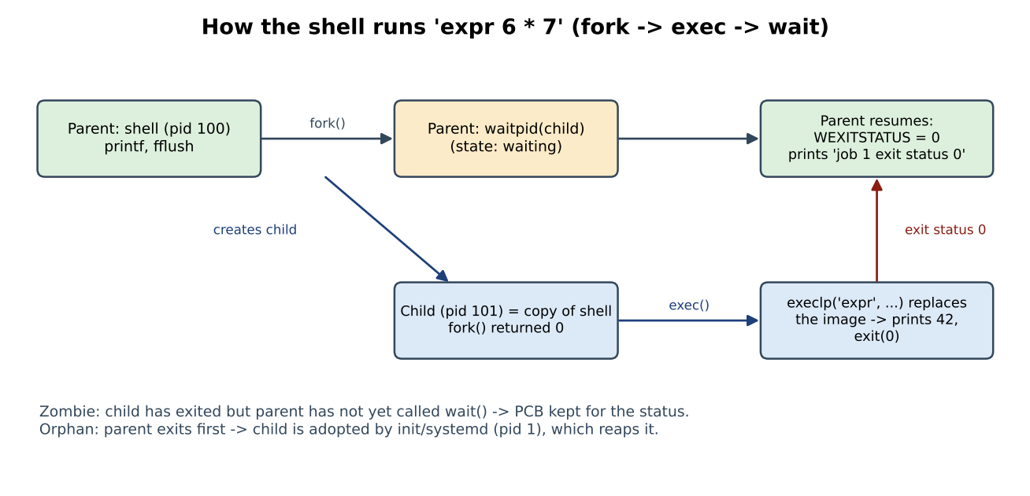
Figure 7.1 – How a shell runs a command: fork → exec → wait.
To run a command the shell calls fork(); the child calls exec() to become the command; the parent calls waitpid() and reads the exit status with WEXITSTATUS(status) (0 = success). The shell stores it as $?.

7.2 Zombies and orphans
- Zombie: a child that has exited but whose parent has not yet called wait(). Only its entry in the process table (PCB with exit status) remains. The parent can reap it with wait(); if the parent never does, zombies accumulate and fill the process table. When the parent exits, init/systemd adopts and reaps them.
- Orphan: a child still running after its parent exited. It is adopted by init/systemd (pid 1), which calls wait() when the orphan ends, so it never becomes a permanent zombie.

7.3 Why fork() followed by exec() rather than one ‘create process’ call?
The gap between fork and exec lets the child change its own environment before running the new program – redirect standard input/output (dup2), set up pipes, change directory, drop privileges, set limits – using ordinary system calls, without a create-process call with dozens of parameters. Because fork shares pages copy-on-write, the copy is cheap. The cost is that fork() must copy the parent's page tables, which grows with the parent's size (measured in 7.6).

7.4 Complete the Code – a shell that runs two jobs
TODO 1 was completed with fork(), execlp("expr", ...) with exit(127) on failure, and waitpid() with WEXITSTATUS. The skeleton uses the variables pid and status without declaring them, so they were declared at the top of main():
#define _POSIX_C_SOURCE 200809L
#include <stdio.h>
#include <stdlib.h>
#include <unistd.h>
#include <sys/wait.h>

int main(void)
{
pid_t pid;
int status;
printf("shell: running job 1\n");
fflush(stdout); /* empty the buffer before fork() */
pid = fork();
if (pid == 0) {
execlp("expr", "expr", "6", "*", "7", (char *)NULL);
exit(127); /* exec failed */
}
waitpid(pid, &status, 0);
printf("job 1 exit status %d\n", WEXITSTATUS(status));

printf("shell: running job 2\n");
fflush(stdout);
pid = fork();
if (pid == 0) _exit(3); /* a child that fails with code 3 */
waitpid(pid, &status, 0);
printf("job 2 exit status %d\n", WEXITSTATUS(status));
return 0;
}
Compiled with gcc -std=c11 -Wall -Wextra shell.c -o shell without warnings. Output (the third screenshot below shows the experiment):

7.5 Why stdout is flushed before each fork(), and the duplicated line
stdout is line-buffered on a terminal but fully buffered when redirected to a file or pipe. fork() copies the whole address space, including the unflushed stdio buffer. If text is still in the buffer at fork(), both the parent and the child hold a copy and each prints it when it flushes – the text appears twice. fflush(stdout) before fork() empties the buffer so the child starts with nothing pending.
Experiment. The second fflush was removed and _exit(3) changed to exit(3) (Task07/shell_variant.c). On a terminal the output is unchanged (each line is flushed at once). With the output redirected to a file, the buffer still contains “job 1 exit status 0” and “shell: running job 2” when the second fork() is called. The child's exit(3) flushes its copy of the buffer, then the parent's own flush at the end prints it again. So “shell: running job 2” appears twice (and so does “job 1 exit status 0”). With _exit(3) the child skips the flush and there would be no duplication – the reason programs use _exit() in the child after fork().
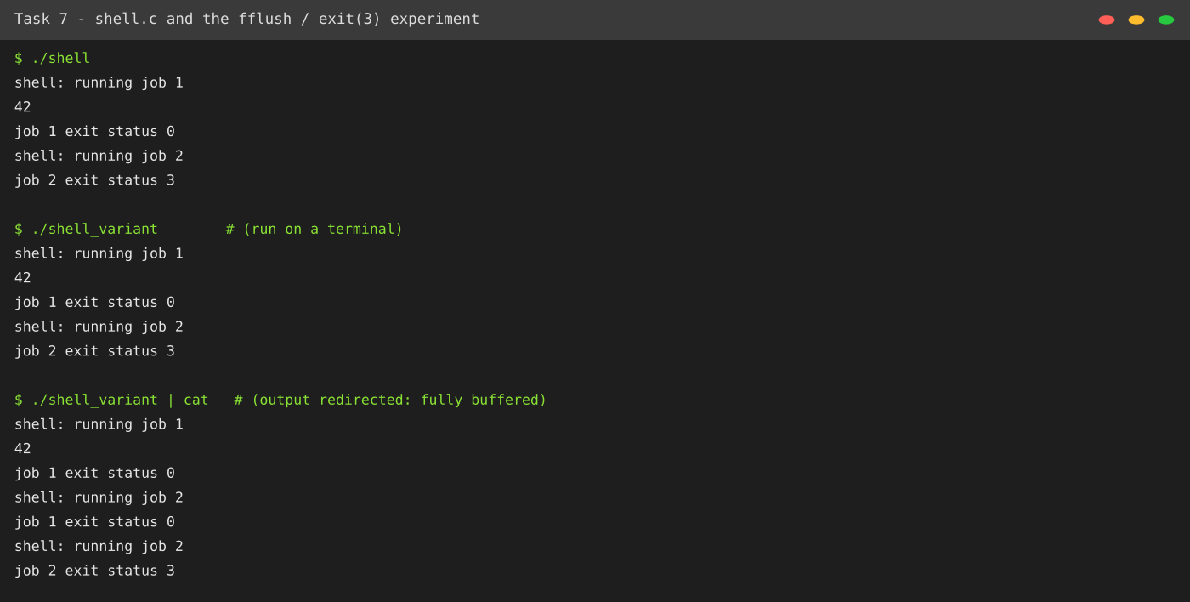
Figure 7.2 – Expected output, behaviour of the variant on a terminal, and the duplicated lines when stdout is redirected.

7.6 Alternative concept and complexity analysis: posix_spawn() or threads instead of fork()+exec()
Solution if it were used. posix_spawn() creates the new process directly from the program path (the C library uses clone with a shared address space, so no copy of the parent's memory is made). Threads would run the command's function inside the same process; they cannot start a different executable.
#define _POSIX_C_SOURCE 200809L
#include <stdio.h>
#include <stdlib.h>
#include <unistd.h>
#include <spawn.h>
#include <sys/wait.h>
#include <time.h>
extern char **environ;
static double now(void) { struct timespec t; clock_gettime(CLOCK_MONOTONIC, &t); return t.tv_sec + t.tv_nsec / 1e9; }
int main(void)
{
const int N = 1000;
size_t mb = 64; char *big = malloc(mb << 20); /* a 64 MB parent, like a database server */
for (size_t i = 0; i < (mb << 20); i += 4096) big[i] = 1;
char *argv[] = {"true", NULL};
double t0 = now();
for (int i = 0; i < N; i++) {
pid_t p = fork();
if (p == 0) { execv("/bin/true", argv); _exit(127); }
waitpid(p, NULL, 0);
}
double tf = now() - t0;
t0 = now();
for (int i = 0; i < N; i++) {
pid_t p;
posix_spawn(&p, "/bin/true", NULL, NULL, argv, environ);
waitpid(p, NULL, 0);
}
double tp = now() - t0;
printf("fork+exec x%d: %.3f s (%.0f us each)\n", N, tf, tf / N * 1e6);
printf("posix_spawn x%d: %.3f s (%.0f us each)\n", N, tp, tp / N * 1e6);
free(big);
return 0;
}
Measured (parent process holding 64 MB of touched memory, starting /bin/true 1,000 times):
Method | Time for 1,000 commands | Per command | Memory copied / shared | Isolation
fork() + exec() | 2.202 s | 2,202 µs | Page tables of the 64 MB parent are copied (16,384 pages) before exec discards them; data pages are copy-on-write | Separate address space, own descriptors
posix_spawn() | 0.855 s | 855 µs | No copy of the parent's pages | Separate address space, same as fork+exec
Threads | n/a – cannot exec a new program; creation costs 32.6 µs (Task 10) | — | Everything shared: heap, globals, descriptors | None – a crash or memory error in one thread kills all
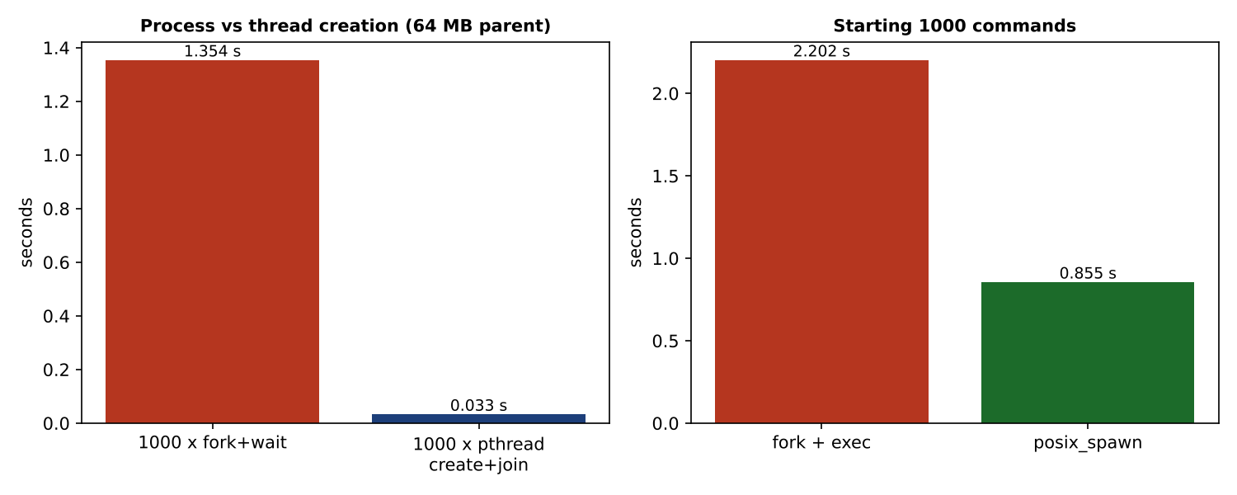
Figure 7.3 – Creation cost: processes vs threads (left) and fork+exec vs posix_spawn (right).
fork+exec costs O(P + E) per command, where P is the parent's mapped memory and E is the cost of loading the new program; posix_spawn costs O(E). For a shell (small parent) the difference is small, but for a 64 MB database server it is 2.6 times; for 1,000 commands it saves 1.3 s. The shell keeps fork+exec for flexibility (redirections, pipes) while the database server should prefer posix_spawn or vfork for bulk command launching.

TASK 8 – Evaluate CPU States and Protection (3 Marks)

8.1 User mode, kernel mode and the mode bit
The CPU has a mode bit (x86: the privilege level in the code-segment register, ring 3 for user and ring 0 for kernel). In kernel mode all instructions are allowed. In user mode, privileged instructions – disabling interrupts (cli), writing the page-table base register, I/O port instructions, halting the CPU, changing the mode bit – cause a protection fault, which the OS turns into a signal that kills the program. The only way from user to kernel mode is through a controlled entry (system call, interrupt or exception) that jumps to a fixed kernel address.

8.2 Interrupts, traps and the timer interrupt
Event | Source | Example in the hospital
Interrupt (asynchronous) | A device or timer signals the CPU. | The sensor ADC has a new sample; the network card has a packet.
Trap / system call (synchronous) | A program deliberately executes a trap instruction. | read() on the database.
Exception (synchronous) | An error caused by an instruction. | Divide by zero; page fault; illegal instruction.
Timer interrupt | A hardware timer fires periodically (for example every 1 ms). | Lets the kernel regain control to pre-empt a running task, enforce time slices and count time. Without it a program in a loop would own the CPU for ever.

8.3 What if any program could disable interrupts?
A buggy or malicious program could execute cli and then loop: the timer interrupt would never fire, so the scheduler could not pre-empt it; the sensor interrupt would not be serviced, so abnormal readings would never reach the alarm task; the watchdog could not be refreshed. The monitor would stop alarming silently – exactly the failure the hospital cannot accept. Hardware therefore makes cli privileged, as the demonstration shows.

8.4 How the hardware stops one program reading another's memory
The MMU translates every virtual address using the current process's page table (the page-table base register is privileged). A process can only name pages that are in its own table; each entry carries present, read/write and user/supervisor bits. An access to an unmapped or forbidden page raises a page fault; the kernel sends SIGSEGV. (On simple microcontrollers a base-and-limit register pair or an MPU performs the same task.)

Demonstration (Task08/protection_demo.c)
#define _POSIX_C_SOURCE 200809L
#include <stdio.h>
#include <stdlib.h>
#include <string.h>
#include <unistd.h>
#include <signal.h>
#include <sys/wait.h>
/* Each test runs in its own child so the hardware/OS reaction can be observed by the parent. */
static void report(const char *what, pid_t p)
{
int st; waitpid(p, &st, 0);
if (WIFSIGNALED(st)) printf("%-48s -> killed by signal %d (%s)\n", what, WTERMSIG(st), strsignal(WTERMSIG(st)));
else printf("%-48s -> exited normally (%d)\n", what, WEXITSTATUS(st));
}
int main(void)
{
pid_t p;
fflush(stdout);
if ((p = fork()) == 0) {
#if defined(__x86_64__) || defined(__i386__)
__asm__ volatile("cli"); /* privileged instruction: disable interrupts */
#elif defined(__aarch64__)
__asm__ volatile("msr daifset, #2"); /* privileged on ARM64: mask IRQ */
#endif
_exit(0);
}
report("user mode runs privileged instruction (cli)", p);
if ((p = fork()) == 0) { volatile int *bad = (int *)8; *bad = 1; _exit(0); }
report("write to an unmapped address (0x8)", p);
if ((p = fork()) == 0) { char *s = "text"; ((volatile char *)s)[0] = 'X'; _exit(0); }
report("write into read-only memory (string literal)", p);
if ((p = fork()) == 0) { char a[4]; (void)a; volatile char *q = (char *)0x7fff00000000ULL; (void)*q; _exit(0); }
report("read another process's address range (guess)", p);
return 0;
}
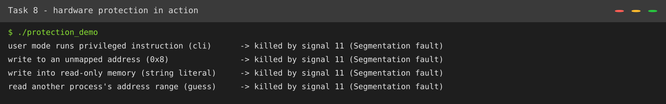
Figure 8.1 – Each violation is stopped by the hardware and the OS kills only the offending process.
Executing the privileged instruction cli in user mode, writing to an unmapped address, writing into read-only memory and reading from an unmapped address all end in signal 11 (SIGSEGV). The parent continued to run: the fault was contained in the child.

8.5 Alternative concept and complexity analysis: polling instead of interrupts
Solution if it were used. The monitor's main loop reads the sensor every T milliseconds and checks for an abnormal value.
while (1) {
v = read_sensor();
if (abnormal(v)) raise_alarm();
sleep_ms(T); /* or busy-wait */
}
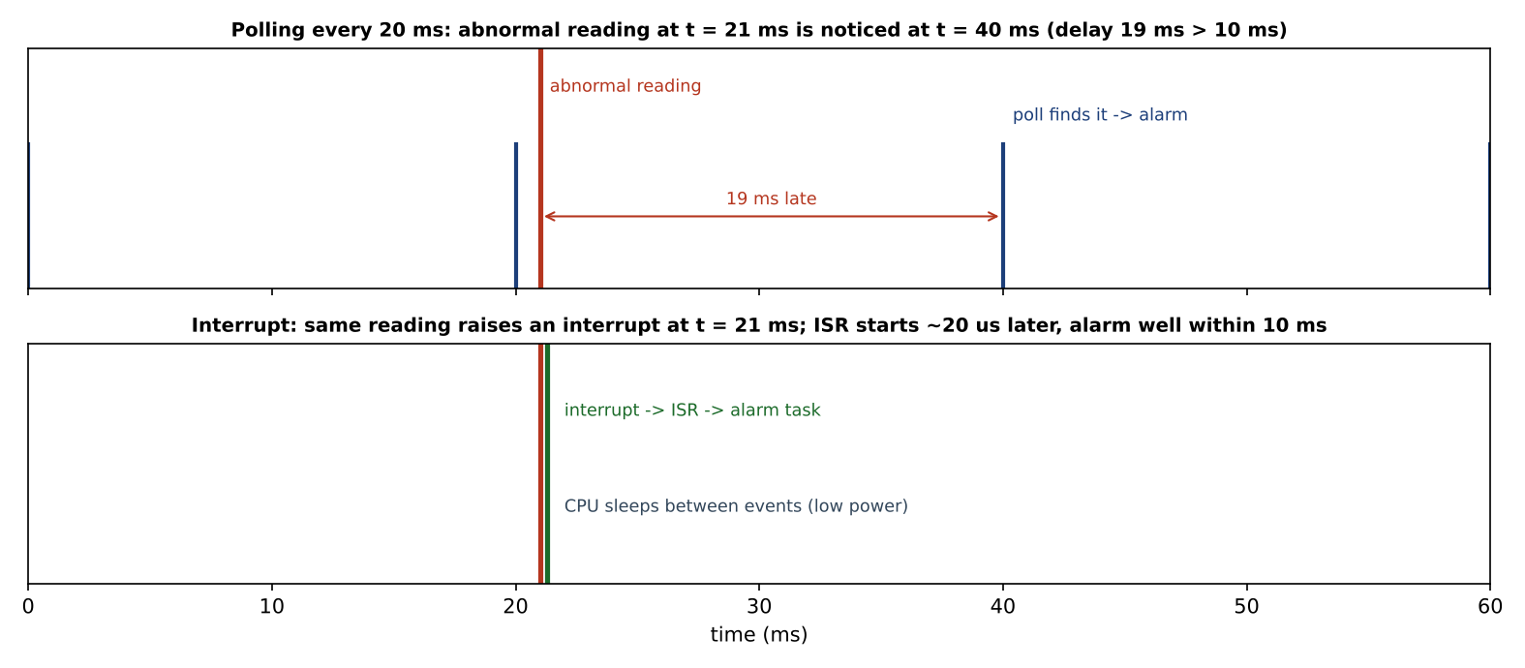
Figure 8.2 – Worst-case detection delay with polling and with an interrupt.
Criterion | Polling every T | Interrupt-driven
Worst-case delay before an abnormal reading is noticed | T (reading arrives just after a poll) + processing. To meet 10 ms with margin T ≤ about 5 ms. T = 20 ms misses the deadline by up to 19 ms. | Interrupt latency, typically 5–50 µs on an RTOS, independent of the sampling interval.
CPU time | 1/T polls per second, each costing c µs: with T = 2 ms and c = 5 µs, 0.25 % per sensor – small, but multiplied by 8 sensors and always running. Complexity O(1/T) per second even when nothing happens. | Work only when an event occurs: O(number of events).
Power | The CPU must wake at every poll and cannot sleep deeply (poor for battery backup during a power cut). | CPU sleeps until the interrupt; lowest power.
T, c and the interrupt latency are illustrative engineering values; the principle – worst-case delay = polling interval versus interrupt latency – is what the task asks to evaluate.
Evaluation. Polling can be made to meet the deadline only by shortening T, which raises CPU use and power; interrupts meet it more strongly and cheaply, so the monitors use interrupt-driven I/O.

TASK 9 – Evaluate the Memory Hierarchy and I/O Systems (4 Marks)

9.1 The memory hierarchy
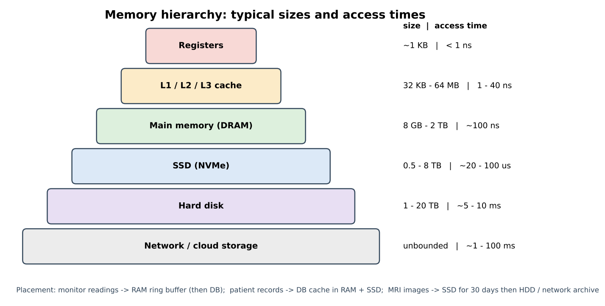
Figure 9.1 – Levels of the hierarchy with typical sizes and access times.
Each level is smaller, faster and more expensive per byte than the one below. A program is fast only if most of its accesses hit the upper levels (locality of reference).

9.2 Where should each kind of data be kept?
Data | Size / rate | Placement | Reason
Monitor readings | A few hundred bytes/s per monitor; must be handled within 10 ms | A ring buffer in the monitor's RAM (battery-backed if needed); batches written to the database server | Only RAM is fast enough for the alarm path; no disk access on the real-time path.
Patient records | Small records, many random look-ups, must be durable | Working set in the database cache in RAM; durable copy on SSD with replicas on a second node; old records on hard disk | Low latency for look-ups (µs instead of ms); SSD gives persistence with random-access speed.
MRI images | 100 MB – several GB per study; sequential | Scanner → DMA → RAM buffer → SSD for the first 30 days (reconstruction, viewing); then hard-disk or network archive | High sequential throughput needed once, then cheap capacity; long retention.

9.3 Programmed I/O, interrupt-driven I/O and DMA
Method | How it works | CPU cost | Suits
Programmed I/O (polling) | The CPU repeatedly checks a device status register and copies each word. | 100 % of the CPU for the whole transfer. | Very simple devices, boot code.
Interrupt-driven I/O | The device interrupts when ready; the CPU copies each word in the handler. | One interrupt per word or small block. | Keyboards, sensors, low data rates – the monitors.
Direct memory access (DMA) | The CPU programs a DMA controller with address and length; the controller moves the whole block to memory and interrupts once. | One setup + one interrupt per block. | MRI scanner, disks, network cards.

9.4 Effect of caching on the speed of record look-up
With hit ratio h, cache access time t_c and miss time t_m, the effective access time is EAT = h·t_c + (1 − h)·t_m. Using t_c = 100 ns (RAM) and t_m = 100 µs (SSD):
Hit ratio h | EAT (RAM cache over SSD) | EAT (RAM cache over 8 ms hard disk)
0.50 | 50 ns + 50,000 ns = 50,050 ns | 50 ns + 4,000,000 ns ≈ 4.0 ms
0.95 | 95 ns + 5,000 ns = 5,095 ns | 95 ns + 400,000 ns ≈ 0.40 ms
0.99 | 99 ns + 1,000 ns = 1,099 ns | 99 ns + 80,000 ns = 80,099 ns ≈ 0.08 ms
Raising the hit ratio from 95 % to 99 % makes look-ups about 4.6 times faster on SSD and 5 times faster on hard disk, so a database cache big enough to hold the working set is the cheapest performance improvement.

9.5 Alternative concept and complexity analysis: interrupt-driven I/O (one interrupt per word) instead of DMA for the MRI scanner
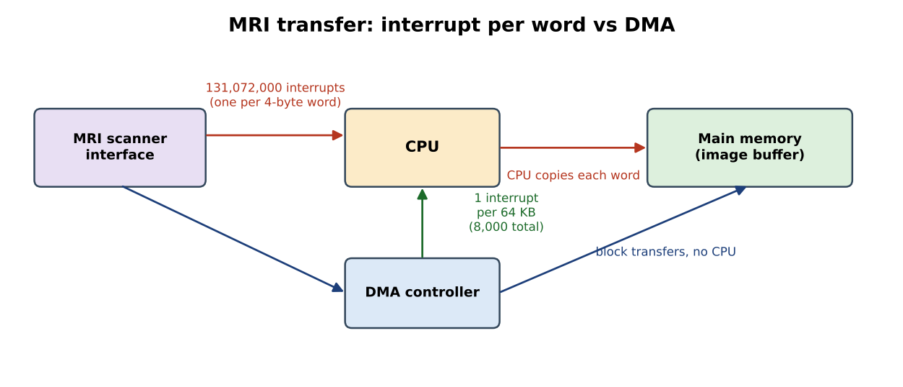
Figure 9.2 – Interrupt per word versus DMA.
Calculation for a 500 MB image (500 × 1,048,576 = 524,288,000 bytes; 4-byte words; assumed 2 µs to service an interrupt and copy one word; DMA with 64 KB blocks):
Criterion | Interrupt per word | DMA, 64 KB blocks
Number of interrupts | 524,288,000 / 4 = 131,072,000 | 524,288,000 / 65,536 = 8,000
CPU time (assumed 2 µs per interrupt) | 131,072,000 × 2 µs ≈ 262 s – the CPU does nothing else | 8,000 × 2 µs = 16 ms (plus the data moves without the CPU)
Complexity | O(n / w) interrupts, w = word size | O(n / B) interrupts, B = block size: 16,384 times fewer
Memory buffers | A destination buffer for the image (500 MB) and a one-word device register | The same 500 MB destination (or a ring of 64 KB buffers) plus a small descriptor list: 8,000 × 16 B = 128 KB
The 2 µs service time is an assumption; the ratio 131,072,000 : 8,000 = 16,384 holds for any service time.
Evaluation. Interrupt-per-word transfer would occupy the CPU for minutes per image and could not keep up with the scanner; DMA is the only practical method, so the plan uses DMA for the scanner, disks and network, and interrupts for monitors' low-rate sensors.

TASK 10 – Measure and Compare (4 Marks)
Test system: Ubuntu 24.04.5 LTS (Linux 6.x), gcc 13.3.0, 2 virtual CPUs. Compile command: gcc -std=c11 -Wall -Wextra -pthread. Absolute times differ from machine to machine; the ratios are the important result.

10.1 System calls for different buffer sizes (strace -c)
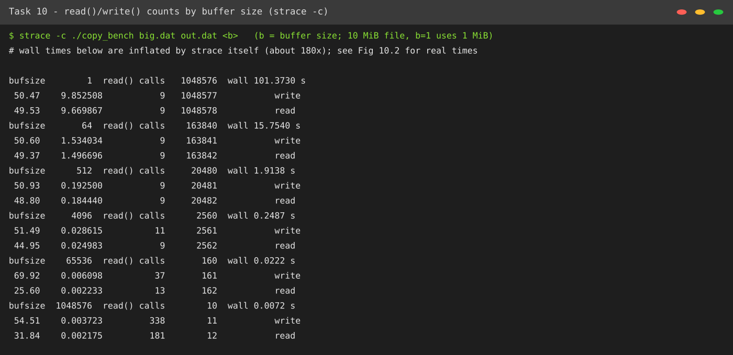
Figure 10.1 – strace -c output for each buffer size (Task10/copy_bench.c).
Buffer b | read() calls | write() calls | Total system-call time under strace
1 byte (1 MiB file) | 1,048,578 | 1,048,577 | 19.5 s
64 bytes | 163,842 | 163,841 | 3.0 s
512 bytes | 20,482 | 20,481 | 0.38 s
4,096 bytes | 2,562 | 2,561 | 0.054 s
65,536 bytes | 162 | 161 | 0.008 s
1,048,576 bytes | 12 | 11 | 0.006 s
The count is ⌈n/b⌉ data reads plus 2 (the end-of-file read and one loader read). Rows other than the first use a 10 MiB file.

10.2 Time in user mode and in kernel mode (time command, 1 MiB copy, best of 3)
Buffer b | real | user | sys (kernel) | Kernel share of CPU time
1 byte | 0.551 s | 0.124 s | 0.422 s | 77 %
16 bytes | 0.038 s | 0.000 s | 0.035 s | ≈ 100 %
64 bytes | 0.011 s | 0.007 s | 0.004 s | 36 %
512 bytes | 0.004 s | 0.000 s | 0.004 s | —
4,096 bytes | 0.003 s | 0.000 s | 0.002 s | —
65,536 bytes | 0.003 s | 0.002 s | 0.000 s | —
1,048,576 bytes | 0.003 s | 0.000 s | 0.002 s | —
With tiny buffers, most of the CPU time is spent in the kernel (trap, validation and return), not in the program's own user-mode code – the cost of system calls described in Task 6. From 512 bytes upward times are a few milliseconds, close to the resolution of the time command, so differences there are not significant.

10.3 Creating 1,000 processes and 1,000 threads
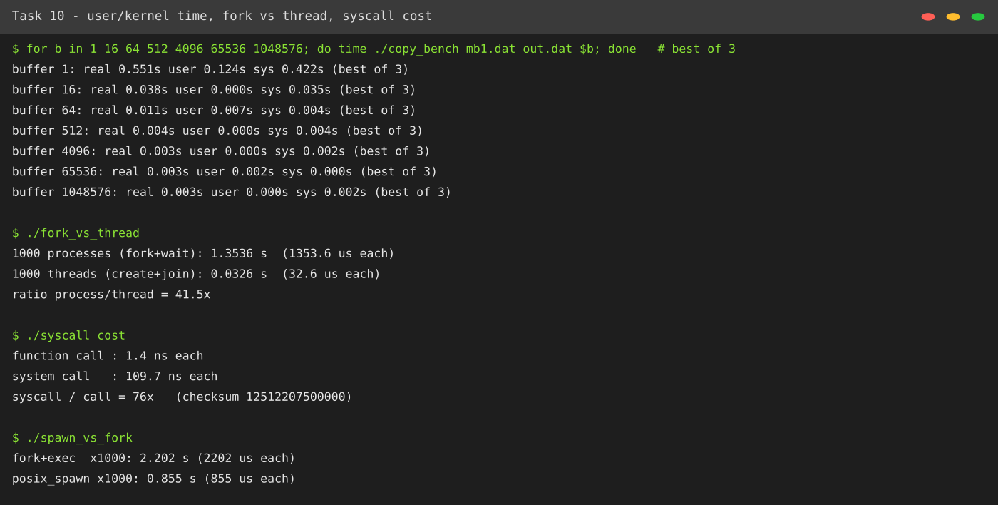
Figure 10.2 – Timing results: user/kernel time, fork vs thread, system-call cost and posix_spawn.
Operation (parent holds 64 MB) | Total for 1,000 | Per creation
fork() + waitpid() | 1.354 s | 1,354 µs
pthread_create() + pthread_join() | 0.033 s | 32.6 µs
Ratio | 41.5 ×

10.4 Do the measurements support the earlier judgements?
Earlier judgement | Measurement | Verdict
A system call is much more expensive than a function call (Task 6). | 110 ns versus 1.4 ns: 76×. | Supported
Larger buffers reduce system calls roughly as n / b (Tasks 5, 6). | Counts match n / b exactly for every buffer size; 1 byte → 4 KB reduced time from 0.55 s to 0.003 s. | Supported
‘A larger buffer is always better.’ | Beyond about 4 KB there is no measurable gain on a 1 MiB file, so the benefit has diminishing returns. | Partly contradicted – refine: choose 64 KiB, not the largest possible.
Library buffering gives about n / 4096 calls (Task 5). | 258 reads for 1 MiB of 1-byte fread calls. | Supported
Threads are cheaper than processes (Tasks 1, 7). | 32.6 µs versus 1,354 µs. | Supported; the gap grows with the parent's memory size.
posix_spawn is cheaper than fork + exec for a large parent (Task 7). | 855 µs versus 2,202 µs. | Supported

10.5 Alternative concept and complexity analysis: threads instead of processes
Creation time. Creating 1,000 threads took 0.033 s versus 1.354 s for 1,000 processes (41.5× faster). Why: a thread shares the address space, open files and heap of its process, so the kernel only allocates a stack and a small thread descriptor. fork() must create a new address space: it duplicates the process descriptor, the file-descriptor table and the page tables (16,384 entries for 64 MB, about 128 KB of page-table memory), marks pages copy-on-write and later takes page faults when either process writes.
Criterion | 1,000 processes | 1,000 threads
Creation time (measured) | 1.354 s: O(P) per fork, P = pages mapped by the parent | 0.033 s: O(1) per thread
Memory used | Own page tables plus private copies of every page written (copy-on-write): grows with the work done | A stack (default 8 MB virtual, only touched pages are resident) and a thread control block; everything else shared
What is shared | Nothing by default (open files are inherited) | Code, heap, globals, file descriptors
Isolation | Strong: a crash affects one process only | None: one faulty thread can kill or corrupt all

TASK 11 – Recommend and Defend the Operating-System Plan (4 Marks)

11.1 The complete plan
Environment | OS type & structure | Services | Protection | I/O method
Bedside monitors | Hard real-time RTOS; microkernel (QNX-class) or FreeRTOS+MPU | Minimal: tasks, interrupts, tiny flash FS, network client, watchdog | Signed firmware, MPU/MMU isolation of tasks, no shell, network VLAN | Interrupt-driven for sensors; DMA for the network
Nurses' tablets | Handheld OS (Android-class); layered over a monolithic kernel | Touch UI, apps, Wi-Fi, camera/barcode, power management | App sandbox, full-disk encryption, MDM remote wipe, MFA | Interrupt-driven, DMA for storage/network
Doctors' workstations | Desktop OS; time-sharing, hybrid or monolithic kernel | GUI, file system, printing, network clients | User accounts, ACLs, MFA, screen lock, disk encryption | Interrupt + DMA
Database cluster | Clustered Linux server; monolithic kernel with loadable modules | Journaling FS, resource control, accounting/audit, replication | ACLs + SELinux, encryption at rest and in transit, audit logs | DMA, large buffers (64 KiB+), RAM cache
Imaging server | Linux SMP server, batch-style job queue | Large-file FS, job scheduling, network | Access limited to radiology group; data encrypted | DMA from the scanner
Partner link | Distributed system: replicated records over VPN/TLS | Communication, authentication, replication | Mutual TLS, per-site keys, audit | Network DMA, batching

11.2 Evidence from this assignment supporting the plan
- Alarm path: polling cannot give both low CPU use and < 10 ms latency (Task 8), and a general-purpose scheduler has no deadline (Task 1) → real-time OS with interrupts.
- System calls cost 76× a function call (Task 6) and fork 41× a thread creation (Task 10) → keep services minimal on monitors, use buffering of 64 KiB for back-ups and threads/pools for the database's many connections.
- A DMA transfer needs 16,384× fewer interrupts (Task 9) → MRI over DMA.
- A cluster gives about 99.999 % availability against 99.8 % for one machine (Task 2) → database cluster.

11.3 Limitations and risks
- Heterogeneity: four OS families need four skill-sets, patch processes and security-scanning tools – the main cost of the plan (Task 1).
- Cluster complexity: split-brain or a failed fencing device can cause an outage or corrupted data; must be tested regularly.
- Real-time guarantee depends on the whole system: a misbehaving driver or an unbounded priority inversion can still break the 10 ms deadline; needs worst-case-latency testing.
- Update risk: firmware updates to 500 monitors must be staged and reversible.
- Measurements were made on a small test machine, so absolute times will differ on hospital hardware.

11.4 Does the plan remain suitable for a group of three hospitals?
Yes, with changes of scale rather than of design: monitors and tablets scale linearly (more devices, same OS); the database moves from one cluster to a cluster per site with replication to the other sites (or a three-site distributed database), and the partner link becomes a mesh of three sites with identical security policy. Central configuration management (Ansible or MDM) is needed because O(k) manual administration for k sites no longer scales.

11.5 Alternative concept and complexity analysis: virtual machines on two large servers
Solution if it were used. All server-side environments (database, imaging, workstation desktops as VDI) would run as virtual machines on two large physical hosts, managed by a type-1 hypervisor (for example KVM).
Criterion | Separate physical machines (chosen) | VMs on two large servers
Response time for monitors | Dedicated, deterministic hardware; deadline guaranteed by the RTOS | Hypervisor scheduling adds jitter (a VM may be descheduled for ms) and a network hop; not suitable for the hard 10 ms alarm path unless a real-time hypervisor with pinned CPUs is used.
Memory and CPU overhead | None | Typically 2–10 % CPU overhead with hardware virtualisation (VT-x/AMD-V), higher for I/O without para-virtual drivers; each VM runs its own guest OS: 0.5–2 GB RAM per VM (O(#VMs × guest OS size)).
Reliability | Failure of one machine affects one environment | Failure of a host takes down every VM on it; the two hosts must each be able to carry the whole load (≤ 50 % utilised); live migration and snapshots speed recovery.
Cost / admin | More hardware, more racks | Fewer machines, easier snapshots and consolidation.
Evaluation. Virtualisation is a good choice for workstations, test systems and parts of the imaging and records tiers, but the monitors must stay on dedicated real-time hardware. The recommended plan is therefore physical for monitors and virtual for part of the back-end.

TASK 12 – Re-evaluate and Adapt the Design (8 Marks)
Changed requirement. Remote monitoring devices in patients' homes send readings over the internet, and patient records move to a cloud service shared with the partner hospitals.
Decision: MODIFY. The core design is retained; new components and security controls are added for the home devices and the cloud.

A. Impact analysis (2 marks)
Part of the original design | Affected? | How
OS type for bedside monitors (hard real-time RTOS) | Retained | Still correct for in-hospital monitors; the home device also needs an embedded RTOS.
New OS environment: home monitors | New | Run on patients' own Wi-Fi: unreliable network, no IT staff, physical access by non-staff, firmware must be updated remotely.
Distributed system (partner link) | Heavily affected | From a few hospital-to-hospital links to a shared cloud service with many clients.
Database cluster (clustered OS) | Modified | No longer the only copy of records; must synchronise with the cloud store.
Services | Modified | Remote update service, device identity, secure communication become essential on the home device.
Protection and security | Most affected | The trust boundary moves from the hospital LAN to the internet: authentication of every device, encryption in transit and at rest, privacy law (consent, audit), key management.
Response time | Affected | Internet round-trip time of tens to 100 ms exceeds the 10 ms alarm deadline.

B. Evaluation of the original design (2 marks)
Criterion | Can the original plan support the change? | Evidence
Response time | No for remote alarms if they depend on the network. The alarm path must stay local to the device; an internet path cannot guarantee 10 ms. | Task 1: hard deadline; Task 8: interrupts make the local alarm bounded; network latency is outside the OS's control.
Reliability | Partly. The cluster is highly available (99.999 %, Task 2), but home devices and the internet are far less reliable, and a cloud outage must not stop the hospital. | Task 2 availability calculation.
Security | No. The original design trusted a closed hospital LAN. Home devices, the internet and a shared cloud need device authentication, TLS, encryption at rest and strict access control. | Task 4 protection model assumed a single organisation.
Scalability | Partly: the cluster scales by adding nodes, but thousands of home devices need an ingestion layer that scales out. | Task 2 Amdahl analysis; Task 11 three-site discussion.

C. Adaptation: the revised design (2 marks)
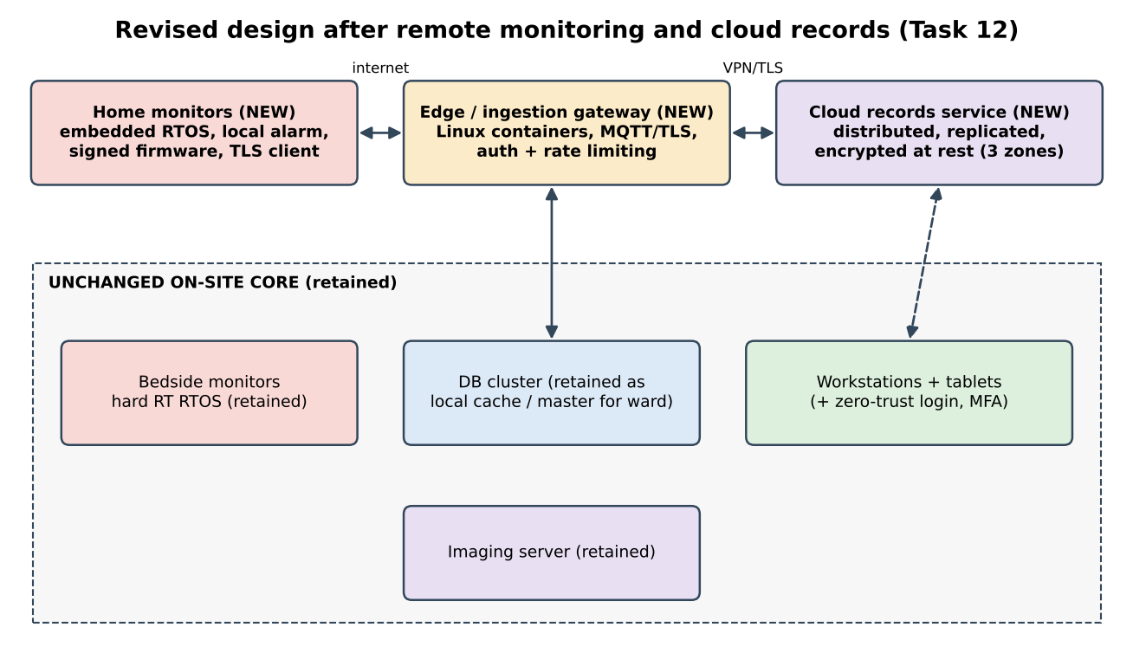
Figure 12.1 – Revised design: new components (top) added to the retained hospital core (bottom).
Component | Design response
Home monitors | Embedded hard real-time RTOS with a local alarm (sound and message) that works even when the internet is down; telemetry is sent as soft real-time data. Secure boot and signed over-the-air firmware updates; unique device certificate; minimal services (no shell, no unused ports); store-and-forward buffer in flash so no readings are lost during a network outage.
Ingestion gateway | Linux containers behind a load balancer: mutual-TLS or MQTT-over-TLS termination, device authentication, rate limiting; scales out horizontally.
Cloud records service | A distributed, replicated store across three availability zones; encryption at rest with hospital-held keys; strong consistency for records, role-based access with audit logs; shared with partner hospitals by per-site policies.
Hospital core | Bedside monitors, database cluster, imaging, tablets and workstations are unchanged. The database cluster stays the system of record for patients in the hospital and replicates to the cloud, so a cloud outage does not stop care. Workstations/tablets gain zero-trust access (MFA, device compliance checks).

D. Evidence-based defence (2 marks)
Decision | Evidence from this assignment | Trade-off accepted
Keep a local, interrupt-driven hard real-time alarm on every device (retain the RTOS choice). | A polling or network-dependent alarm cannot give a bounded worst case; interrupts give microseconds (Task 8). Internet RTT of tens of ms is larger than the 10 ms deadline. | Home devices need more memory and cost than a ‘dumb’ sensor.
Retain the clustered database as the on-site master and replicate to the cloud. | Cluster ≈ 99.999 % vs single machine ≈ 99.8 % (Task 2); on-site data keeps working through an outage. | Two copies of the data: replication traffic, storage, and consistency effort.
Use a distributed, replicated cloud store with three zones. | Replication protects against failure of one site; distributed systems share records across partner hospitals (Task 2). | Eventual or higher-latency consistency across sites; trust in the cloud provider; legal controls on location of patient data.
Add device authentication, TLS and encryption (modified protection model). | Task 4: protection depends on authentication, access control and encryption; the trust boundary has moved. | CPU and energy cost of cryptography on small devices (hardware AES helps); key-management effort.
Keep monitors off general virtual machines. | Task 11: hypervisor jitter threatens the deadline. | Less consolidation, more hardware.
Final decision. The original design is modified, not redesigned: its OS choices (hard real-time RTOS, clustered Linux database, SMP imaging server) remain correct because the safety requirement – a bounded local alarm – has not changed. What changed is the trust boundary and the scale, so the revision adds an embedded RTOS for home devices, a scalable ingestion tier, a distributed replicated cloud store and a zero-trust protection model. A full redesign would discard components whose evidence still holds and add risk without benefit.

APPENDIX A – Repository, README and How to Reproduce

A.1 Repository layout (CSA04-192521359-Assignment1)
CSA04-192521359-Assignment1/
README.md
Task01/ ... Task04/ (report text, tables)
Task05/ read_demo.c, patient.txt, strace_read_demo.txt
Task06/ copy_file.c, mmap_copy.c, syscall_cost.c, output.txt, strace_summary.txt
Task07/ shell.c, shell_variant.c, spawn_vs_fork.c, output.txt, variant_*.txt
Task08/ protection_demo.c, protection_demo.txt
Task10/ copy_bench.c, stdio_copy.c, fork_vs_thread.c, strace and timing outputs
figs/ diagrams and screenshots used in the report

A.2 Environment (record in README.md)
Item | Value used for the results in this report
Linux distribution | Ubuntu 24.04.5 LTS (x86-64), 2 virtual CPUs
Compiler | gcc 13.3.0
Compile command | gcc -std=c11 -Wall -Wextra -pthread file.c -o file
Tools | strace, bash time, python3 + matplotlib for the figures
The numbers in Tasks 6, 7, 8 and 10 were measured on this machine. Run every program again on your own computer and replace the numbers and screenshots with yours before you submit; the viva may ask you to run any program.

A.3 Commands to run and the commit history (one commit per task, at least)
# Task 5
cd Task05 && gcc -std=c11 -Wall -Wextra read_demo.c -o read_demo && strace ./read_demo
# Task 6
cd ../Task06 && gcc -std=c11 -Wall -Wextra copy_file.c -o copy_file && ./copy_file
strace -c -f -e trace=read,write ./copy_file > /dev/null
gcc -std=c11 -Wall -Wextra mmap_copy.c -o mmap_copy && strace -c ./mmap_copy in.dat out.dat
# Task 7
cd ../Task07 && gcc -std=c11 -Wall -Wextra shell.c -o shell && ./shell
gcc -std=c11 -Wall -Wextra shell_variant.c -o shell_variant && ./shell_variant | cat
# Task 8
cd ../Task08 && gcc -std=c11 -Wall -Wextra protection_demo.c -o protection_demo && ./protection_demo
# Task 10
cd ../Task10 && gcc -std=c11 -Wall -Wextra copy_bench.c -o copy_bench
head -c 1048576 /dev/urandom > mb1.dat && time ./copy_bench mb1.dat out.dat 4096
gcc -std=c11 -Wall -Wextra -pthread fork_vs_thread.c -o fork_vs_thread && ./fork_vs_thread

# git
git init && git add Task05 && git commit -m "Task 5: system calls and strace"
git add Task06 && git commit -m "Task 6: copy_file, buffer-size study, mmap"
git add Task07 && git commit -m "Task 7: shell with fork/exec/wait"
git add Task08 && git commit -m "Task 8: protection demo"
git add Task10 && git commit -m "Task 10: measurements"
git add . && git commit -m "Report and README"
git remote add origin <your repository URL> && git push -u origin main

APPENDIX B – Additional Program Listings

B.1 copy_bench.c – read()/write() copy with any buffer size (Task 10)
#define _POSIX_C_SOURCE 200809L
#include <stdio.h>
#include <stdlib.h>
#include <fcntl.h>
#include <unistd.h>
#include <time.h>

/* Usage: copy_bench src dst bufsize -- copies with read()/write(), prints read() count and time */
int main(int argc, char **argv)
{
if (argc != 4) { fprintf(stderr, "usage: %s src dst bufsize\n", argv[0]); return 2; }
size_t bs = (size_t)atol(argv[3]);
char *buf = malloc(bs);
int in = open(argv[1], O_RDONLY), out = open(argv[2], O_WRONLY | O_CREAT | O_TRUNC, 0644);
if (in < 0 || out < 0 || !buf) { perror("open/malloc"); return 1; }
struct timespec a, b; clock_gettime(CLOCK_MONOTONIC, &a);
long reads = 0; ssize_t n;
while ((n = read(in, buf, bs)) > 0) { reads++; if (write(out, buf, (size_t)n) != n) { perror("write"); return 1; } }
clock_gettime(CLOCK_MONOTONIC, &b);
close(in); close(out); free(buf);
printf("bufsize %8zu read() calls %9ld wall %.4f s\n", bs, reads,
(b.tv_sec - a.tv_sec) + (b.tv_nsec - a.tv_nsec) / 1e9);
return 0;
}

B.2 stdio_copy.c – fread/fwrite copy (Tasks 5, 6)
#define _POSIX_C_SOURCE 200809L
#include <stdio.h>
#include <stdlib.h>
/* fread/fwrite copy with 1-byte-at-a-time calls: library buffering batches the real system calls */
int main(int argc, char **argv)
{
if (argc != 3) return 2;
FILE *in = fopen(argv[1], "rb"), *out = fopen(argv[2], "wb");
if (!in || !out) { perror("fopen"); return 1; }
int c; long n = 0;
while (fread(&c, 1, 1, in) == 1) { fwrite(&c, 1, 1, out); n++; }
fclose(in); fclose(out);
printf("library calls: %ld fread + %ld fwrite\n", n, n);
return 0;
}

B.3 fork_vs_thread.c – process and thread creation time (Task 10)
#define _POSIX_C_SOURCE 200809L
#include <stdio.h>
#include <stdlib.h>
#include <unistd.h>
#include <pthread.h>
#include <sys/wait.h>
#include <time.h>

#define COUNT 1000
static double now(void) { struct timespec t; clock_gettime(CLOCK_MONOTONIC, &t); return t.tv_sec + t.tv_nsec / 1e9; }
static void *worker(void *arg) { (void)arg; return NULL; }

int main(void)
{
/* give the process a realistic heap so fork() has page tables to copy: 64 MB touched */
size_t mb = 64; char *big = malloc(mb << 20);
for (size_t i = 0; i < (mb << 20); i += 4096) big[i] = 1;

double t0 = now();
for (int i = 0; i < COUNT; i++) {
pid_t p = fork();
if (p == 0) _exit(0);
waitpid(p, NULL, 0);
}
double tf = now() - t0;

t0 = now();
for (int i = 0; i < COUNT; i++) {
pthread_t t;
pthread_create(&t, NULL, worker, NULL);
pthread_join(t, NULL);
}
double tt = now() - t0;
printf("%d processes (fork+wait): %.4f s (%.1f us each)\n", COUNT, tf, tf / COUNT * 1e6);
printf("%d threads (create+join): %.4f s (%.1f us each)\n", COUNT, tt, tt / COUNT * 1e6);
printf("ratio process/thread = %.1fx\n", tf / tt);
free(big);
return 0;
}

B.4 syscall_cost.c – function call versus system call (Task 6)
#define _GNU_SOURCE
#include <stdio.h>
#include <unistd.h>
#include <sys/syscall.h>
#include <time.h>
/* Compare an ordinary (non-inlined) function call with a real system call (getppid). */
__attribute__((noinline)) long plain_call(long x) { __asm__ volatile("" : "+r"(x)); return x + 1; }
static double now(void) { struct timespec t; clock_gettime(CLOCK_MONOTONIC, &t); return t.tv_sec + t.tv_nsec / 1e9; }
int main(void)
{
const long N = 5000000; long s = 0;
double t0 = now();
for (long i = 0; i < N; i++) s += plain_call(i);
double tf = now() - t0;
t0 = now();
for (long i = 0; i < N; i++) s += syscall(SYS_getppid);
double ts = now() - t0;
printf("function call : %.1f ns each\n", tf / N * 1e9);
printf("system call : %.1f ns each\n", ts / N * 1e9);
printf("syscall / call = %.0fx (checksum %ld)\n", ts / tf, s);
return 0;
}

B.5 shell_variant.c – experiment for the duplicated line (Task 7)
Identical to shell.c except that the second fflush(stdout) is removed and _exit(3) is replaced by exit(3):
diff shell.c shell_variant.c
22d21
< fflush(stdout);
24c23
< if (pid == 0) _exit(3); /* a child that fails with code 3 */
---
> if (pid == 0) exit(3); /* a child that fails with code 3 */

APPENDIX C – Quick Viva Preparation
Likely question | Short answer
Why can the alarm not run on a general-purpose OS? | The fair-share scheduler gives no worst-case bound; a real-time OS guarantees a deadline.
Why is read() slower than a function call? | Trap, mode switch, argument validation and return: measured 110 ns versus 1.4 ns.
What is the effect of the buffer size? | Calls = n / b; the benefit flattens after about 4 KB; I recommend 64 KiB.
Why did “shell: running job 2” print twice? | Unflushed stdout buffer was copied by fork(); exit(3) in the child flushed it again.
Why is cli killed in user mode? | It is a privileged instruction: the CPU raises a fault when the mode bit says user.
Why DMA for the MRI? | 16,384 times fewer interrupts than one interrupt per 4-byte word.
Why is Task 12 ‘modify’ and not ‘redesign’? | The safety requirement and the OS choices behind it are unchanged; the trust boundary and scale changed.

